Working App Evidence Document (See the screen capture attached to the folder - Screen_capture_working_app.PNG)

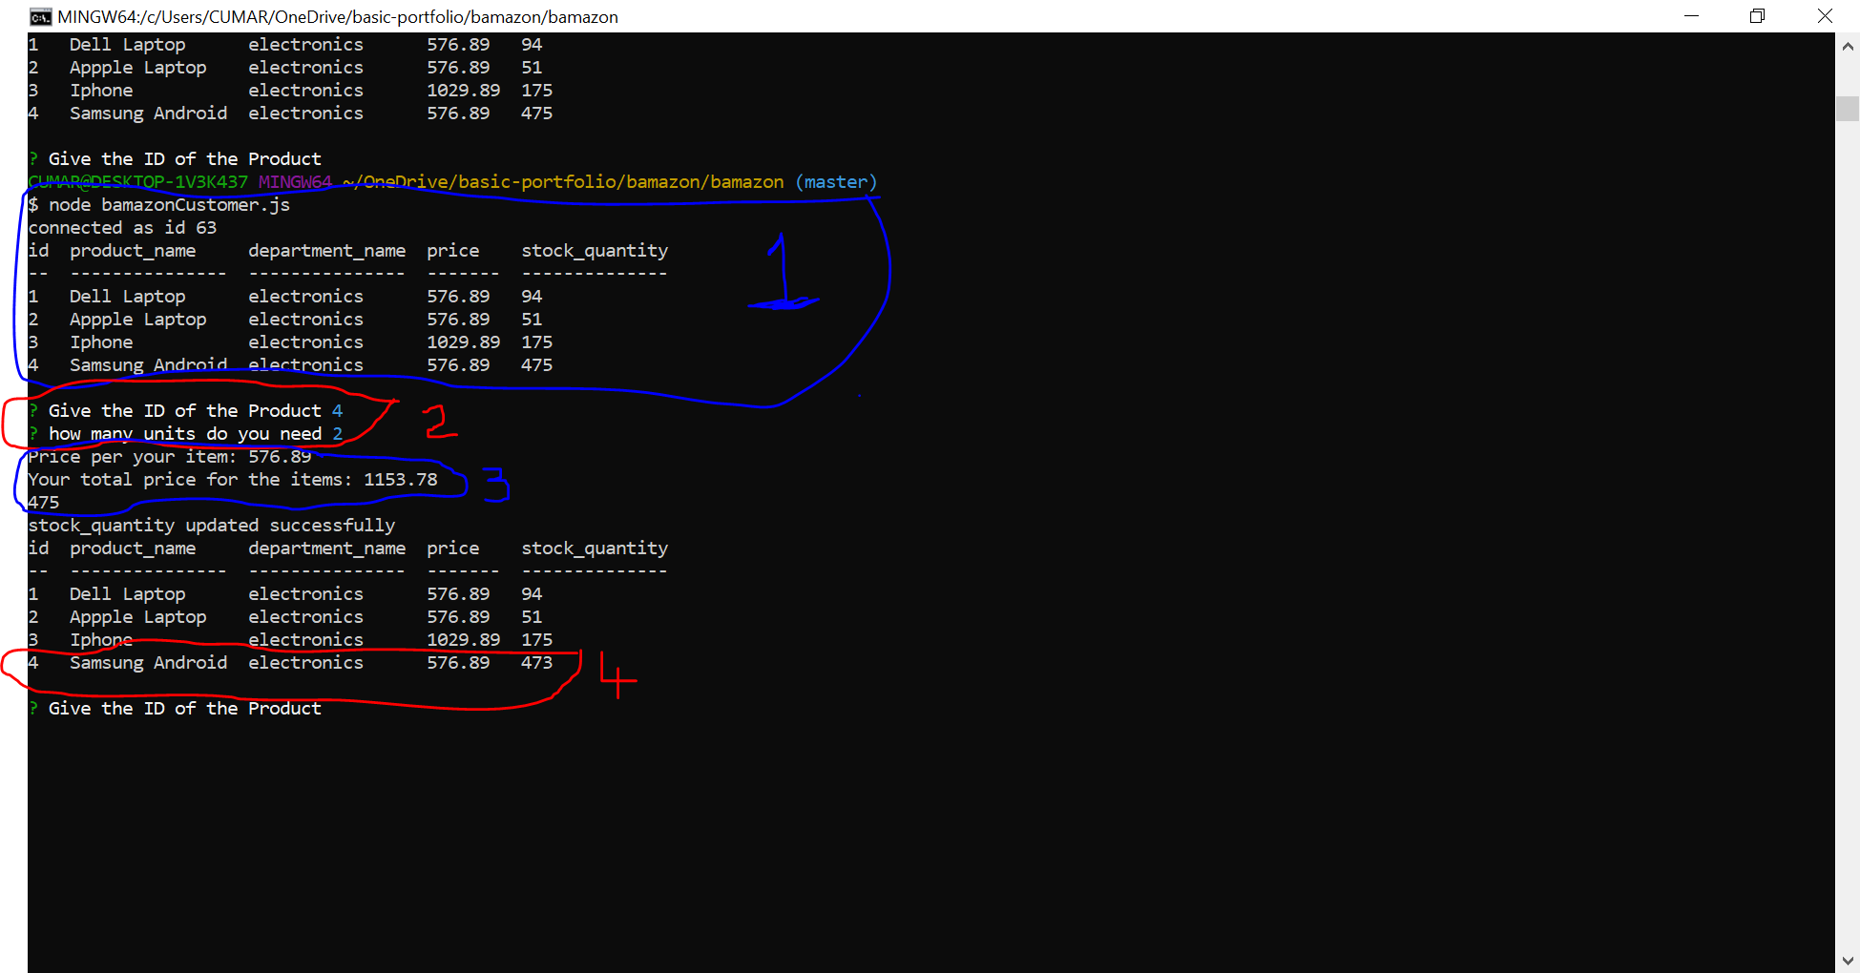

1. Highlighted in blue #1 shows the select query pulling the table data
2. Highlighted in Red # 2, gets the user input of Item ID and Item Qty
3. Highlighted in Blue #3, shows the price per item and total of the purchased items.
4. Highlighted in Red #4, shows the table is reduced by the Item Qty bought.

Negative qty requested by the customer (Negative_test_when_not_enough_time_to_sell.PNG)

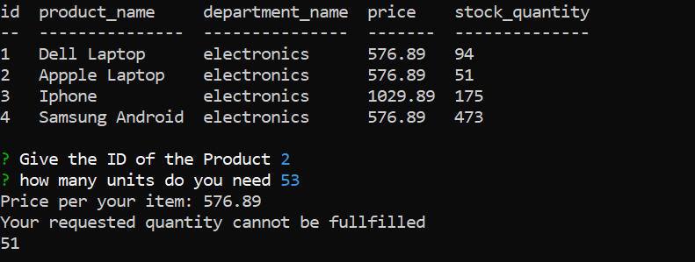

When the customer request for more than available, app returns a user friendly message to let them know, QTY not available